Q.// write a program to add of two number

#addition of two number

a=int(input("enter the first number:"))

b=int(input("enter the second number:"))

c=a+b

print(a,"+",b,"=",c)

output:

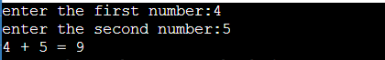

Q.//write a program to find the remainder when divided by 2

#remainder of any number

a=int(input("enter the number:"))

print("the remainder is",a%2)

output:



Q.// write a program to find the type of variable

#type of variable

a=input("enter the any thing:")

print(type(a))

output:



Q.//write a program to find the greater number

#checking the operators condition

a=int(input("enter the first number:"))

b=int(input("enter the second number:"))

if a>b:

print(a,"is greater than",b)

elif a==b:

print(a,"is equal to",b)

else:

print(a,"is less than ",b)

output:



Q.//write a program to find the average of two number

#average of two numbers

a=int(input("enter the first number:"))

b=int(input("enter the second number:"))

print("the average of",a,"and",b,"is",(a+b)/2)

output:

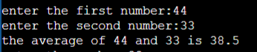

Q.//write a program to find the square of number

#square of the number

a=int(input("enter the number:"))

print("the square of",a,"is",a\*\*2)

output:



Q. #Write a Python program to display a user-entered name followed by Good Afternoon using input() function

name=input("enter the name:")

print("Good Afternoon "+name)

output:



Q. #Write a program to fill in a letter template given below with name and date.

name=input("enter the name:")

print('''letter=\'\" Dear '''+name,'''

                        You are selected!

                        Date:14/10/22

''')

Output:

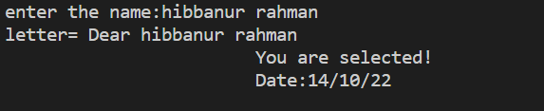

Q. #Write a program to detect double spaces in a string.

a=input("enter the any string:")

b=a.count("  ")

print("the double spaces in ",a," is ",b)

output:



Q. #Replace the double spaces from problem 3 with single spaces.

a.replace("  "," ")

print(a)

output:

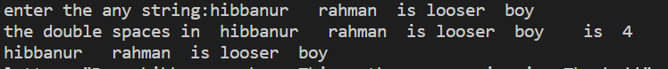

Q.// #Write a program to format the following letter using escape sequence characters

print("letter=","\"Dear "+name,"This python course in nice.Thanks!!\"")

output:



Q. # write a program to store seven fruits in a list entered by the user.

b=[]

for x in range(0,7):

    a=input("enter the fruits name:")

    b.append(a)

print("the list is:")

print(b)

output:-

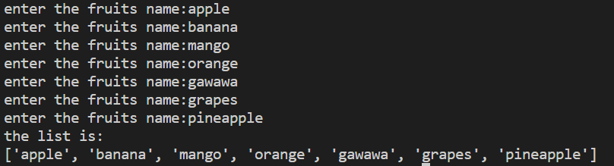

Q. # write a program to accept marks of 6 students and display them in a sorted manner

marks=[]

for x in range(0,6):

    print("enter the marks of",x+1,"th student:")

    a=input()

    marks.append(a)

list.sort(marks)

print(marks)

output:-

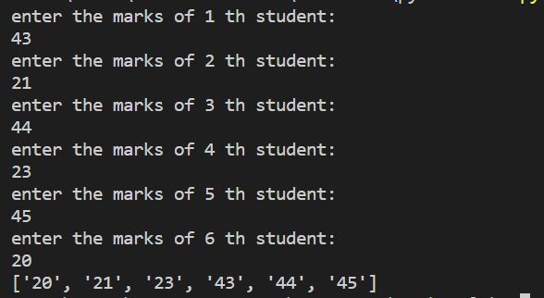

Q. #write a program to sum a list with 4 numbers

number=[]

sum=0

print("enter the numbers:")

for x in range(0,4):

    a=int(input())

    number.append(a)

    sum=sum+number[x]

print("the sum of",number,"is ",sum)

output:

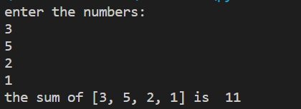

Q. #write a program to count the number of zeroes in the following tuple

a=(7,0,8,0,0,9)

b=a.count(0)

print("the number in the tupple ",a,"is",b)

output:-

